Game Controls

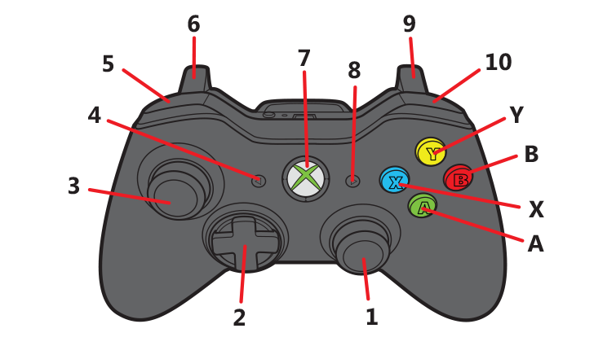

|  |  |  |
| --- | --- | --- |
| **Button Number / Letter** | **Name** | **Functionality** |
| **1** | **Right Analog Stick** | N/A |
| **2** | **Directional Pad** | N/A |
| **3** | **Left Analog Stick** | **Move the player character** |
| **4** | **Back Button** | **Resets the level** |
| **5** | **Left Bumper** | **Rotate camera left** |
| **6** | **Left Trigger** | **Deform terrain downwards** |
| **7** | **Xbox Button** | N/A |
| **8** | **Start Button** | N/A |
| **9** | **Right Trigger** | **Deform terrain downwards** |
| **10** | **Right Bumper** | **Rotate camera right** |
| **A** | **A Button (Green)** | **Jump** |
| **B** | **B Button (Red)** | **Zoom camera in** |
| **X** | **X Button (Blue)** | **Zoom camera out** |
| **Y** | **Y Button (Yellow)** | **Interact with switches** |

Xbox Controller Diagram : <https://support.xbox.com/en-US/xbox-360/accessories/controllers>